

AP® Physics C
2000 Free response Questions

The materials included in these files are intended for use by AP teachers for course and exam preparation in the classroom; permission for any other use must be sought from the Advanced Placement Program®. Teachers may reproduce them, in whole or in part, in limited quantities, for face-to-face teaching purposes but may not mass distribute the materials, electronically or otherwise. These materials and any copies made of them may not be resold, and the copyright notices must be retained as they appear here. This permission does not apply to any third-party copyrights contained herein.

These materials were produced by Educational Testing Service® (ETS®), which develops and administers the examinations of the Advanced Placement
Program for the College Board. The College Board and Educational Testing Service (ETS) are dedicated to the principle of equal opportunity, and their
programs, services, and employment policies are guided by that principle.

The College Board is a national nonprofit membership association dedicated to preparing, inspiring, and connecting students to college and opportunity.
Founded in 1900, the association is composed of more than 4,200 schools, colleges, universities, and other educational organizations. Each year, the
College Board serves over three million students and their parents, 22,000 high schools, and 3,500 colleges, through major programs and services in
college admission, guidance, assessment, financial aid, enrollment, and teaching and learning. Among its best-known programs are the SAT®, the
PSAT/NMSQT®, and the Advanced Placement Program® (AP®). The College Board is committed to the principles of equity and
excellence, and that commitment is embodied in all of its programs, services, activities, and concerns.

APIEL is a trademark owned by the College Entrance Examination Board. PSAT/NMSQT is a registered trademark jointly owned by the College Entrance Examination Board and the National Merit Scholarship Corporation. Educational Testing Service and ETS are registered trademarks of Educational Testing Service.

(2000 M1) You are conducting an experiment to measure the acceleration due to gravity g_{u} at an unknown location. In the measurement apparatus, a simple pendulum swings past a photogate located at the pendulum's lowest point, which records the time t₁₀ for the pendulum to undergo 10 full oscillations. The pendulum consists of a sphere of mass m at the end of a string and has a length l. There are four versions of this apparatus, each with a different length. All four are at the unknown location, and the data shown below are sent to you during the experiment.

(cm) | t₁₀  (s) | T  (s) | T²  (s²)
12 | 7.62
18 | 8.89
32 | 12.08
a. For each pendulum, calculate the period T and the square of the period. Use a reasonable number of significant figures. Enter these results in the table above.
b. On the axes below, plot the square of the period versus the length of the pendulum. Draw a best-fit straight line for this data.
c. Assuming that each pendulum undergoes small amplitude oscillations, from your fit determine the experimental value g_{exp} of the acceleration due to gravity at this unknown location. Justify your answer.
d. If the measurement apparatus allows a determination of g_{u} that is accurate to within 4%, is your experimental value in agreement with the value 9.80 m/s² ? Justify your answer.
e. Someone informs you that the experimental apparatus is in fact near Earth's surface, but that the experiment has been conducted inside an elevator with a constant acceleration a. Assuming that your experimental value g is exact, determine the magnitude and direction of the elevator's acceleration.

2000M2. A rubber ball of mass m is dropped from a cliff. As the ball falls, it is subject to air drag (a resistive force caused by the air). The drag force on the ball has magnitude bv², where b is a constant drag coefficient and v is the instantaneous speed of the ball. The drag coefficient b is directly proportional to the cross-sectional area of the ball and the density of the air and does not depend on the mass of the ball. As the ball falls, its speed approaches a constant value called the terminal speed.
a. On the figure below, draw and label all the forces on the ball at some instant before it reaches terminal speed.

b. State whether the magnitude of the acceleration of the ball of mass m increases, decreases, or remains the same as the ball approaches terminal speed. Explain.
c. Write, but do NOT solve, a differential equation for the instantaneous speed v of the ball in terms of time t, the given quantities, and fundamental constants.
d. Determine the terminal speed v_{t} in terms of the given quantities and fundamental constants.
e. Determine the energy dissipated by the drag force during the fall if the ball is released at height h and reaches its terminal speed before hitting the ground, in terms of the given quantities and fundamental constants.

165

2000M3. A pulley of radius R₁ and rotational inertia I₁ is mounted on an axle with negligible friction. A light cord passing over the pulley has two blocks of mass m attached to either end, as shown above. Assume that the cord does not slip on the pulley. Determine the answers to parts (a) and (b) in terms of m, R₁, I₁, and fundamental constants.
a. Determine the tension T in the cord.
b. One block is now removed from the right and hung on the left. When the system is released from rest, the three blocks on the left accelerate downward with an acceleration g/3 . Determine the following.
i. The tension T₃ in the section of cord supporting the three blocks on the left
ii. The tension T_{l} in the section of cord supporting the single block on the right
iii. The rotational inertia I₁ of the pulley

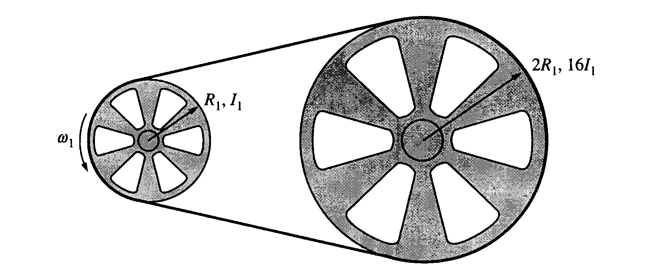

c. The blocks are now removed and the cord is tied into a loop, which is passed around the original pulley and a second pulley of radius 2R₁ and rotational inertia 16I₁. The axis of the original pulley is attached to a motor that rotates it at angular speed ω₁, which in turn causes the larger pulley to rotate. The loop does not slip on the pulleys. Determine the following in terms of I₁, R_{I}, and ω₁.
i. The angular speed ω₂ of the larger pulley
ii. The angular momentum L₂ of the larger pulley
iii. The total kinetic energy of the system

166

2000E1. Lightbulbs A, B, and C are connected in the circuit shown above.
a. List the bulbs in order of their brightness, from brightest to least bright. If any bulbs have the same brightness, state which ones. Justify your answer.

Now a switch S and a 5.0 mH inductor are added to the circuit; as shown above. The switch is closed at time t = 0.

b. Determine the currents I_{A}, I_{B}, and I_{C} for the following times.
i. Immediately after the switch is closed
ii. A long time after the switch is closed

c. On the axes below, sketch the magnitude of the potential difference V_{L} across the inductor as a function of time, from immediately after the switch is closed until a long time after the switch is closed.

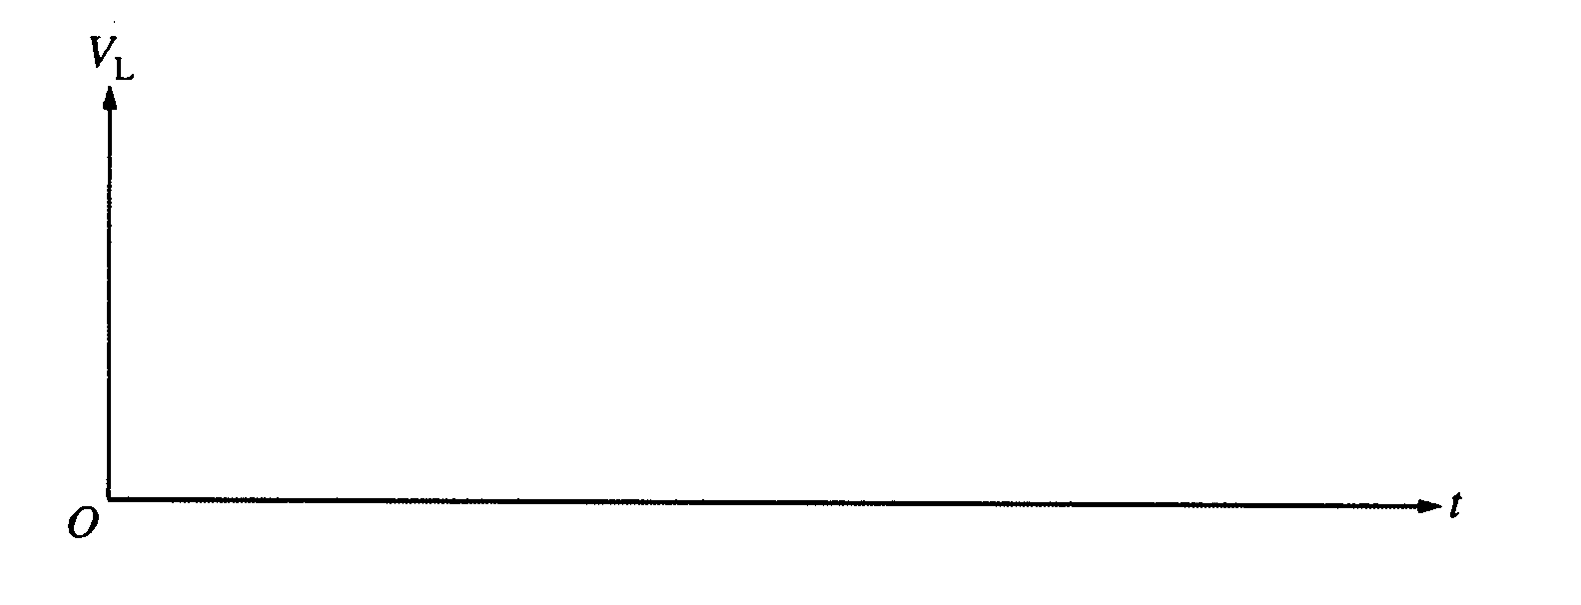

d. Now consider a similar circuit with an uncharged 5.0 μF capacitor instead of the inductor, as shown above. The switch is again closed at time t = 0. On the axes below, sketch the magnitude of the potential difference V_{cap} across the capacitor as a function of time, from immediately after the switch is closed until a long time after the switch is closed.

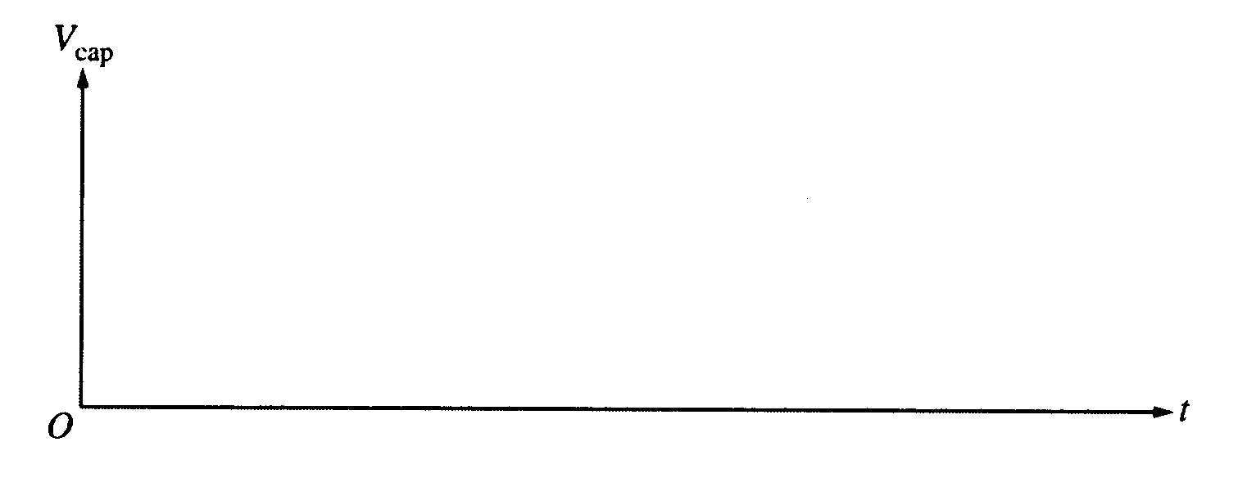

2000E2. Three particles, A, B, and C, have equal positive charges Q and are held in place at the vertices of an equilateral triangle with sides of length f, as shown in the figures below. The dotted lines represent the bisectors for each side. The base of the triangle lies on the x-axis, and the altitude of the triangle lies on the y-axis.
167

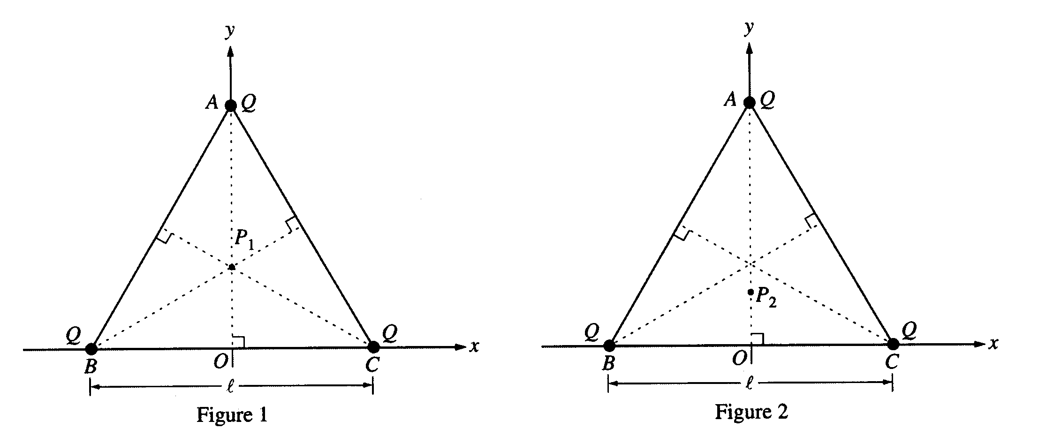
a.
i. Point P₁, the intersection of the three bisectors, locates the geometric center of the triangle and is one point where the electric field is zero. On Figure 1 above, draw the electric field vectors E_{A}, E_{B}, and E_{C} at P, due to each of the three charges. Be sure your arrows are drawn to reflect the relative magnitude of the fields.

ii. Another point where the electric field is zero is point P₂ at (0, y₂). On Figure 2 above, draw electric field vectors E_{A}, E_{B}, and E_{C} at P₂ due to each of the three point charges. Indicate below whether the magnitude of each of these vectors is greater than, less than, or the same as for point P₁.
 | Greater than at P₁ | Less than at P₁ | The same as at P₁
E_{A}
E_{B}
E_{C}

b. Explain why the x-component of the total electric field is zero at any point on the y-axis.
c. Write a general expression for the electric potential V at any point on the y-axis inside the triangle in terms of Q, l, and y.
d. Describe how the answer to part (c) could be used to determine the y-coordinates of points P₁ and P₂ at which the electric field is zero. (You do not need to actually determine these coordinates.)

2000E3. A capacitor consists of two conducting, coaxial, cylindrical shells of radius a and b, respectively, and length L >> b. The space between the cylinders is filled with oil that has a dielectric constant x. Initially both cylinders are uncharged, but then a battery is used to charge the capacitor, leaving a charge +Q on the inner cylinder and -Q on the outer cylinder, as shown above. Let r be the radial distance from the axis of the capacitor.
a. Using Gauss's law, determine the electric field midway along the length of the cylinder for the following values of r, in terms of the given quantities and fundamental constants. Assume end effects are negligible.
i. a < r < b
ii. b < r << L
b. Determine the following in terms of the given quantities and fundamental constants.
i. The potential difference across the capacitor
ii. The capacitance of this capacitor

c. Now the capacitor is discharged and the oil is drained from it. As shown above, a battery of emf ε is connected to opposite ends of the inner cylinder and a battery of emf 3ε is connected to opposite ends of the outer cylinder. Each cylinder has resistance R. Assume that end effects and the contributions to the magnetic field from the wires are negligible. Using Ampere's law, determine the magnitude B of the magnetic field midway along the length of the cylinders due to the current in the cylinders for the following values of r.
i. a < r < b
ii. b <r << L

